AroundWellington.com – November 2015 issue
Paws-itive Press
Hounds & Heroes Program, Celebrating Veteran’s Day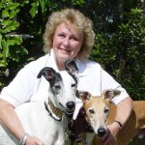
Veteran’s Day is a public holiday held on the anniversary of the end of World War I (November 11) to honor US veterans and victims of all wars. It replaced Armistice Day in 1954. We now memorialize the contributions of veterans from all wars this day – an honor they deserve for their part in keeping our country free.
There are many organizations that devote themselves to helping our veterans – but the ones that fit this column on animals are those that provide them with service dogs. Locally we have a very unique group training and donating the fully trained dogs to veterans. Awesome Greyhound Adoptions created their Hounds and Heroes program specifically for the purpose of training the retired racers as service dogs and donating them to veterans in need. This is an all-volunteer group, where the donations received go to the care of the dogs – not to salaries of employees.
“For 23 years I have walked with a cane” said Frank as he practiced with Buff during Buff’s transition period from trainer to veteran. “Now I have Buff, and no longer need the cane.”
“The changes in the lifestyle of the veteran AND his family is truly amazing” states Carolee Ellison, head trainer. “AGA’s Hounds and Heroes train for those with MS, Parkinson’s, Traumatic Brain Injury, PTSD, and those in need of mobility assistance.”
It would take a book to record all the comments from the veterans and their family members as an endorsement of the program. The dogs are selected carefully for the program – they must be young and uninjured and eager to learn. They are born as athletes – working dogs – and although many are 45 mile per hour couch potatoes, some do like to work. And as a working dog they are with their veteran owner 24/7 and not left at home alone. It is a win/win situation for veteran and greyhound alike.
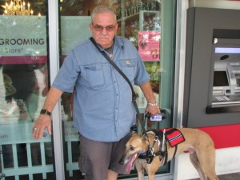
Veteran Frank with his service dog Buff, thanks to the Hounds & Heroes program. Photo by Krista Martinelli.
“Training is a six month process,” said Ellison. “The dogs live with the trainer and go with them to work / shopping / restaurants while training. They usually are matched with a veteran during that time and the last one or two months of the training process is with the trainer, the dog and the veteran together. We also provide ongoing training should the dog need to learn a new discipline to assist the veteran.”
From the wife of one of our veterans who received his dog a few months ago: ‘I can’t possibly put into words how unbelievably thankful I am. In the past two months I have slowly watched my husband evolve back into the confident, independent man that I married. This amazing dog hasn’t just changed my husband’s life but our entire family. I have not gone anywhere without my husband in over 4 years. My husband was a tanker in the army. He was one of the first men to be sent to Iraq after 9/11 and was in an active war zone for over a year and a half. It is heart breaking to watch such a strong, selfless man come back from war – broken. Most people will never understand the battles that he faces daily. For the past several years he has only occasionally gone out into public for fear of crowds or something startling him. He has missed out on birthday parties, school functions and numerous events that he would have normally loved.
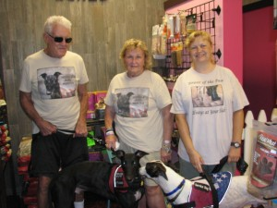
Promoting Hounds & Heroes. Middle: Barbara Masi. Right: Carolee Ellison. At the ice cream social in August at Woof Gang Bakery in Wellington .
“From the moment he was handed the leash for his dog you could see a noticeable difference in his demeanor. It was the first time I had ever seen him able to sit and just hold a conversation in public. I cried the whole way home. He didn’t walk with him the first day, but hey – he was in a mall! The next time we went, we walked into the mall as usual and sat with the group. I was talking with the others and heard my husband say “Stormy, let’s go” and he walked off all by himself with Stormy glued to his side! I burst into tears! As long as I live I will never be able to ever forget that moment. Something like this might seem so simple to someone else, but I saw my strong brave husband take back his freedom.”
There is so much more I could write about this program – but I don’t believe it would surpass the comments above. For further information visit AwesomeGreyhoundAdoptions.org and see the story of the Hounds and Heroes program.
© Barbara Masi 2015
***

Barbara Masi has been a resident of Boynton Beach for 35 years and an animal advocate all her life. Although having many breeds of dogs in the past, she has devoted the last 15 years to the re-homing of retired racing greyhounds and is the founder of a group that trains them as service dogs and donates them to veterans. Barbara works with local school children in educating them about animal kindness and anti-bullying through PBSO’s Animal Kindness Unit. Through her employment, she has the opportunity to interact with a variety of local animal groups and businesses, allowing her to share their knowledge of all animals to us at AroundWellington.com.

