Military branches compete to raise funds for Hounds & Heroes compete to
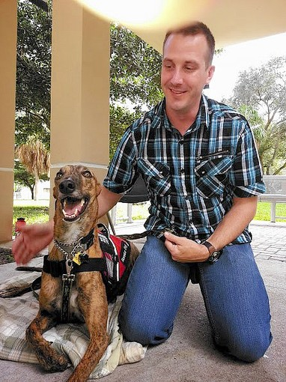
War veteran Karl Burtzloff bonds with his new greyhound Hero. (submitted photo, FPG / January 8, 2014)

Jan Engoren jengoren@tribune.com
January 8, 2014
Awesome Greyhound Adoptions, a volunteer-run, nonprofit agency dedicated to finding homes for retired racing greyhounds is partnering with the Hounds & Heroes program to provide veterans with greyhounds for pets, therapy dogs or as fully-trained service dogs.
To help defray the costs of training, food and medical care, Hounds & Heroes is running a contest between the Army, Navy and Marines to see who will donate the most to sponsor a greyhound for a veteran.
Barbara Masi, president of Awesome Greyhound Adoptions, said, "I've been working with greyhounds for 14 years and they make great pets and great service dogs."
"Therapy dogs make his or her owner feel more comfortable with the dog than without," she said. "You can take a service dog everywhere – to the movies, to the mall and to restaurants."
Over the past two years, her agency has placed five dogs with local veterans and currently has two dogs being trained and has identified their new homes and owners.
Karl Burtzloff, 36, a veteran of the Iraqi war, was selected as a recipient of a greyhound service dog. He is medically retired from the Army and has been diagnosed with multiple sclerosis.
"I can hardly wait," he said about receiving Hero, his retired racing dog. "I fell head over heels in love with Hero."
Due to his medical condition, Burtzloff said, "Hero will help me with my balance and coordination issues. When I met him, he leaned against me and it made me feel more stable and secure."
He was so impressed with Masi and her adoption program that he became a volunteer.
"I got a good feeling from the organization and Barbara is amazing," Burtzloff said. "She's very informative and keeps me up-to-date on Hero's progress.
"I've had dogs in the past, but Hero will be my first service dog. When the opportunity came up, I couldn't turn it down," he said.
Sally Saxon and Jeff Nelson of Mutts and Jeff LLC in Delray Beach, both professional dog trainers with more than 20 years experience apiece, are two of the greyhound trainers preparing the dogs from the racing track to their new roles as service dogs.
Nelson is training Hero for Burtzloff and Saxon is training 4-year-old Rocky for another veteran.
"We give these dogs a second life," said Saxon, who took Rocky with her and her family to Naples over Christmas vacation as part of his socialization process.
"Greyhounds are very calm dogs," she said. "They will lay on the couch with you. They get along well with other dogs and people. They're sweet dogs."
Nelson and Saxon teach the dogs basic commands, how to walk on a leash, how to sit and lay down.
The dogs must pass a canine good citizen test administered by the American Kennel Club showing that they have the necessary skills to be a good citizen in the canine community.
Nelson finds the work especially rewarding because these dogs have been singular-minded in their racing careers, but are able to learn new skills.
"A dog's best life is living with a family and having a relationship as a pack member," he said. "Their lives improve and they improve the lives of the veterans at the same time."
Awesome Greyhound Adoptions is looking for sponsors and trainers. Email Barbara Masi at barbaramasi@comcast.net or call 561-737-1941.
To sponsor a greyhound, visit AwesomeGreyhoundAdoptions.org or send a check to: Awesome Greyhound Adoptions, 226 SE First Ave., Boynton Beach, FL 33435 with a note in the memo section as to the branch of service you wish to support.
Copyright © 2014, South Florida Sun-Sentinel

